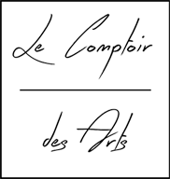

Cahier des charges

Dobrescu Alexandru-Serafim

Ingesup B 1

Short presentation of the project.

The main targets of this project are to display a pleasant design connected to the functional part of an e-commerce site. The subject of the site is an art gallery and the theme of the site is minimalism. As a whole, the viewer takes a pause of what's more than 90% of the web, why? Because most of the web contains a heavy design with a lot of elements, some of them pop out, other one's have flashy sparkles to distract the attention from the main subject and of course let's not forget about the many adds that are everywhere.

I chose this type of design to let the viewer enjoy of what I think is a digital gallery art focused on the subject without any distraction. I added some subtle effects for hover but nothing major.

Why do we need another digital gallery art? Since everything is found instantly on internet, we have access to a lot of information almost instantly. But the important aspect is not the information as quantity, it’s the way you deliver the information. In my vision a gallery art is an experience that let you enjoy and think about the artist composition. But on my experience so far viewing some online gallery arts, the way they delivered the information was from a noisy background. Just a few showed an elegant way to display it.

From a marketing point of view, this niche of digital art gallery, isn’t the main attraction of the buyers. Mostly because people enjoy more the idea of art, than art itself. The real buyers won't go to a site to buy it. They will go to a site to view it and know when and where they need to be to buy it. But since the main purpose of the site is to be an e-commerce site, on gallery section it will be displayed the function of adding to cart and of course the checkout. But I tend to believe the interest of the real buyers is lost by adding those.

Objectives of the project.

The main objectives:

1. To offer a good way to deliver art composition
2. To sell art
3. To offer a solution of BackEnd
4. To give a styled site for an art gallery

Retrospective time involved

More than 200 hours, between doing dev side and debugging what doesn’t work.

On whom targets this site?

The type of site isn’t addressed to huge part of population, since most of them won't value the qualities expressed. This site targets what I consider it’s the most important part of art buyers, people with culture, maturity and a clear vision. I'm sure it can also attract an untrained eye but they will rather chose to share it among their friends to impress them with what they found than actually buying it. Nevertheless this behavior is good in marketing.

The structure of the site

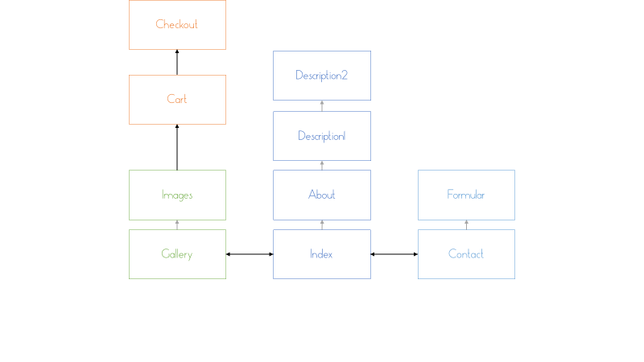

The structure involves the minimum number of pages, because its rather annoying to go to a lot of pages than just scroll a little more.

The maquette

Homepage

Section 1/4

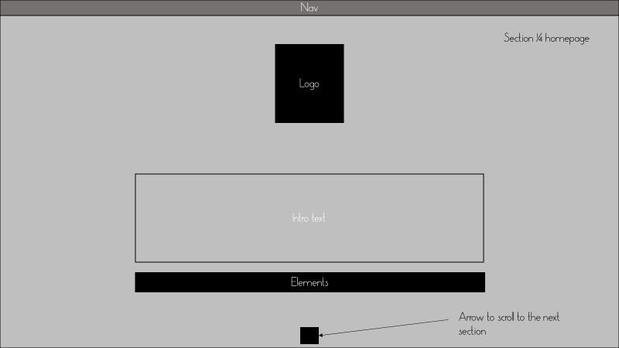

Section 2/4

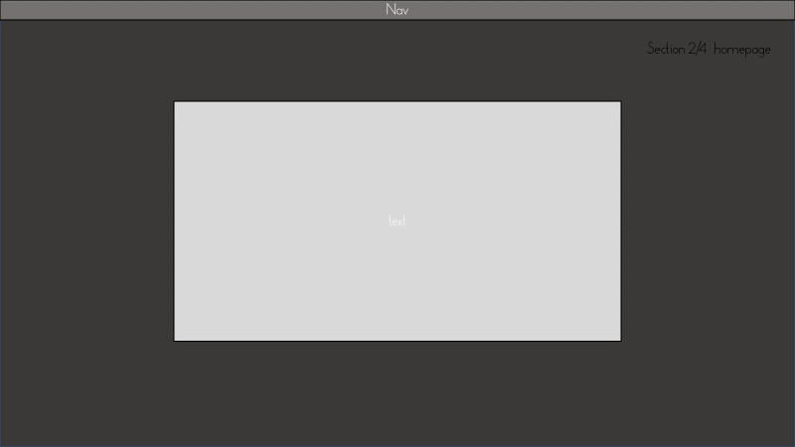

Section 3/4

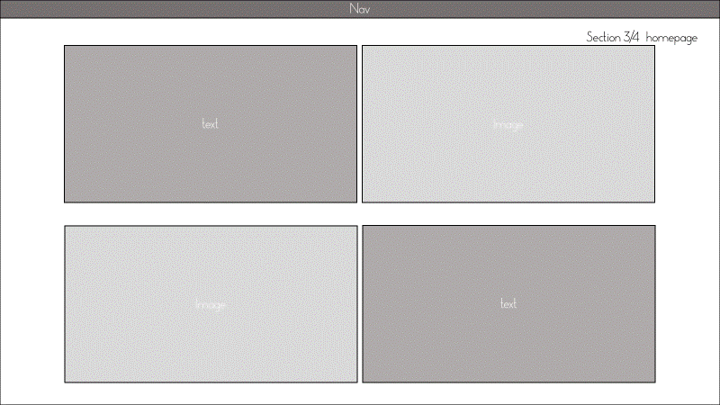

Section 4/4

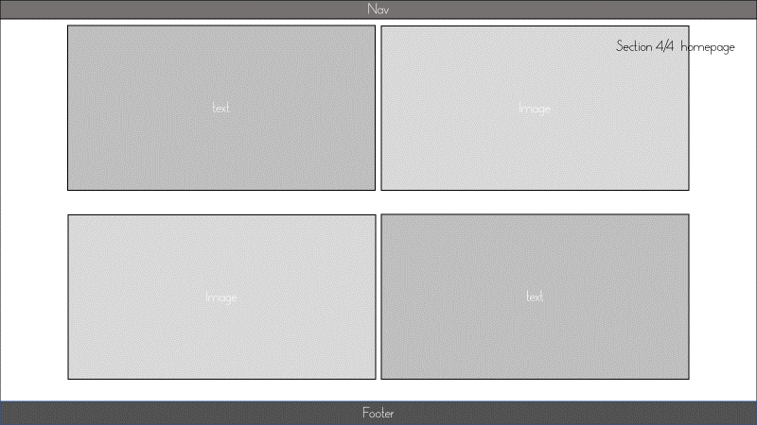

Gallery page

Section 1/3

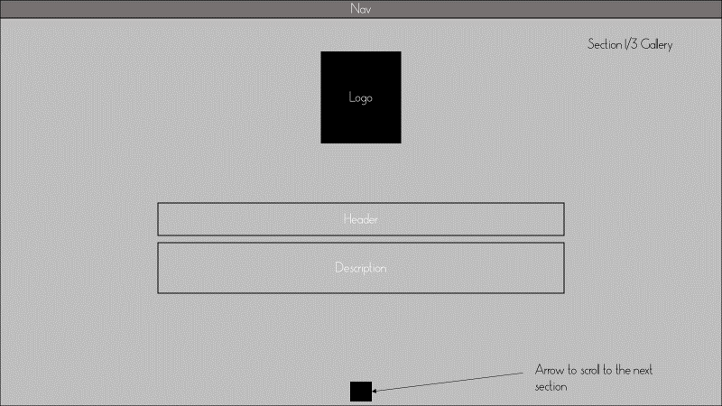

Section 2/3

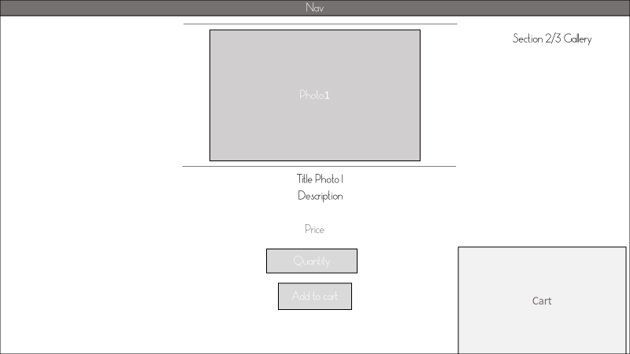

Section 3/3

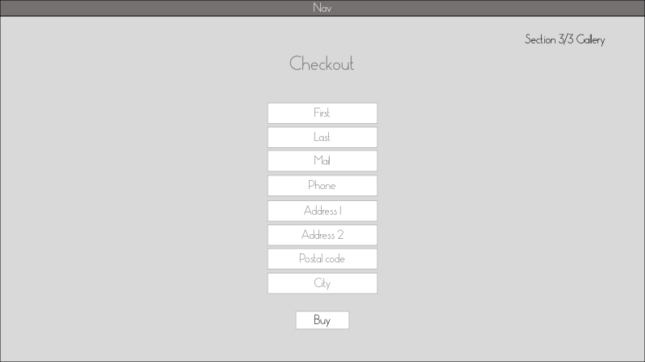

Contact page

Section 1 / 1

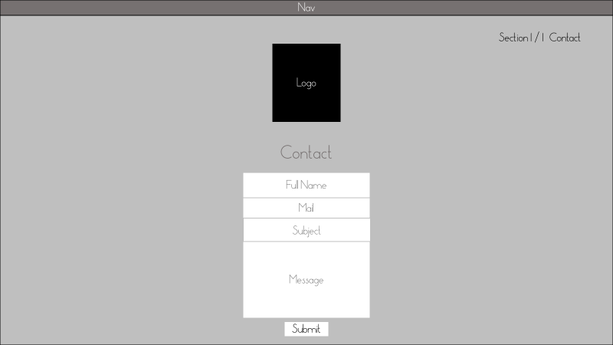

What does it contain?

* On the Homepage the site will have in section one a short description. On the next section it will be displayed a presentation of the company. On the last 2 sections we will describe the most iconic photos we have on the site.
* On the Gallery we will have a plain section only with a welcome message. On the 2nd section it will be displayed from database all the photo gallery and for each photo it will be also displayed a title, a description, a price and in the end the quantity and the buy button. On the last section of the gallery it will be integrated the checkout form and on top right, the cart with the items.
* Last page is Contact page, the functionality of the page is just to have a communication between viewer and admin via email.
* On each page is present the google analytics script to view and track the activity of users.
* The code of the page is valid w3c and is supported on updated all browsers.

Languages of the site

Currently on the site is supported only English, the main reason is that the only dev this project has, controls better English than French. The other reason is English opens the opportunity for a larger audience.

If the site attracts some attention on a particular country, in the future, it will be translated in that language. But I think is not something necessary since English is the main language on the internet.

Content:

The site comes with 9 products entries on database that show photos with title, description and price. On the text aspect is just test text.

About users the functionality is tested but currently there are none, and as well on the commands there are none.

Development:

On the dev side, the Gallery page calls the database to display the products and as well it has the function to register buyers and commands on the checkout section.

For the Gallery currently its supported just the add function on the backend. That means we can enter photos without doing it on the database, but on the other hand, it lacks the function to delete. Therefore, the delete is needed to be done manually into the database.

Also, as note, the products need to respect the theme of the site, so in other words the 9 products are as an reference to the composition needed.

On this site it wasn’t used any type of frameworks, html, css, php and sql are from scratch.

The code for the Sql database is in the documentation folder, and as well there are the MCD, MLD, MPD. For better visualization of MCD and MLD there is a file called MCD2.mcd that is opened with an application called JMerise.

The BackEnd is not indexed, only the admin knows the address.

The address by default should end with \Includes\BackEnd\backendGallery.php

Naming of the site

The site currently is named "Le Comptoir des Arts" but it can be changed. The domain isn’t something reserved with a fee, and in that case, it won't be shown by default into a google search.

Hosting

The site is hosted on a free server, with some limited features, but as a preview it works. For further usage, it's advised to move to a better host, fee may be included.

Updating

The site doesn’t support a backend update of the text. It requires just a minimum knowledge of html to modify the text. Or if needed I can deliver a tutorial on how to change it.

The result

Homepage

Section 1 / 4

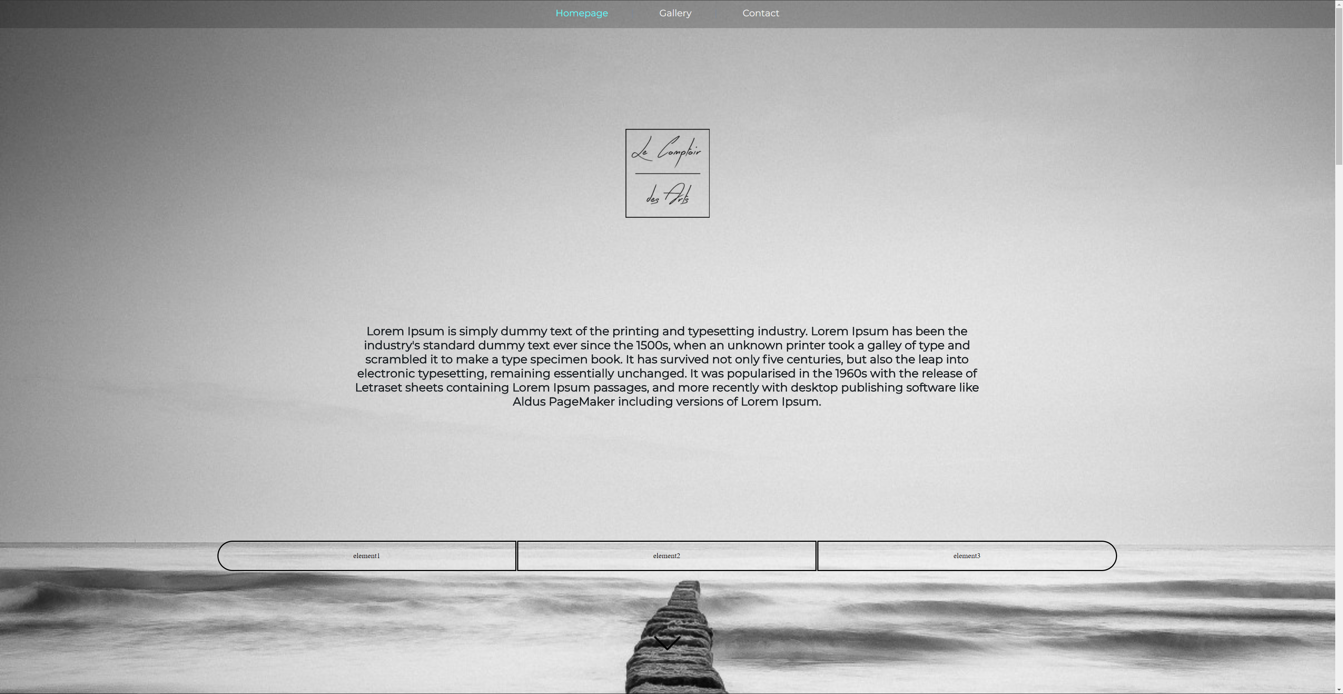

Section 2/ 4

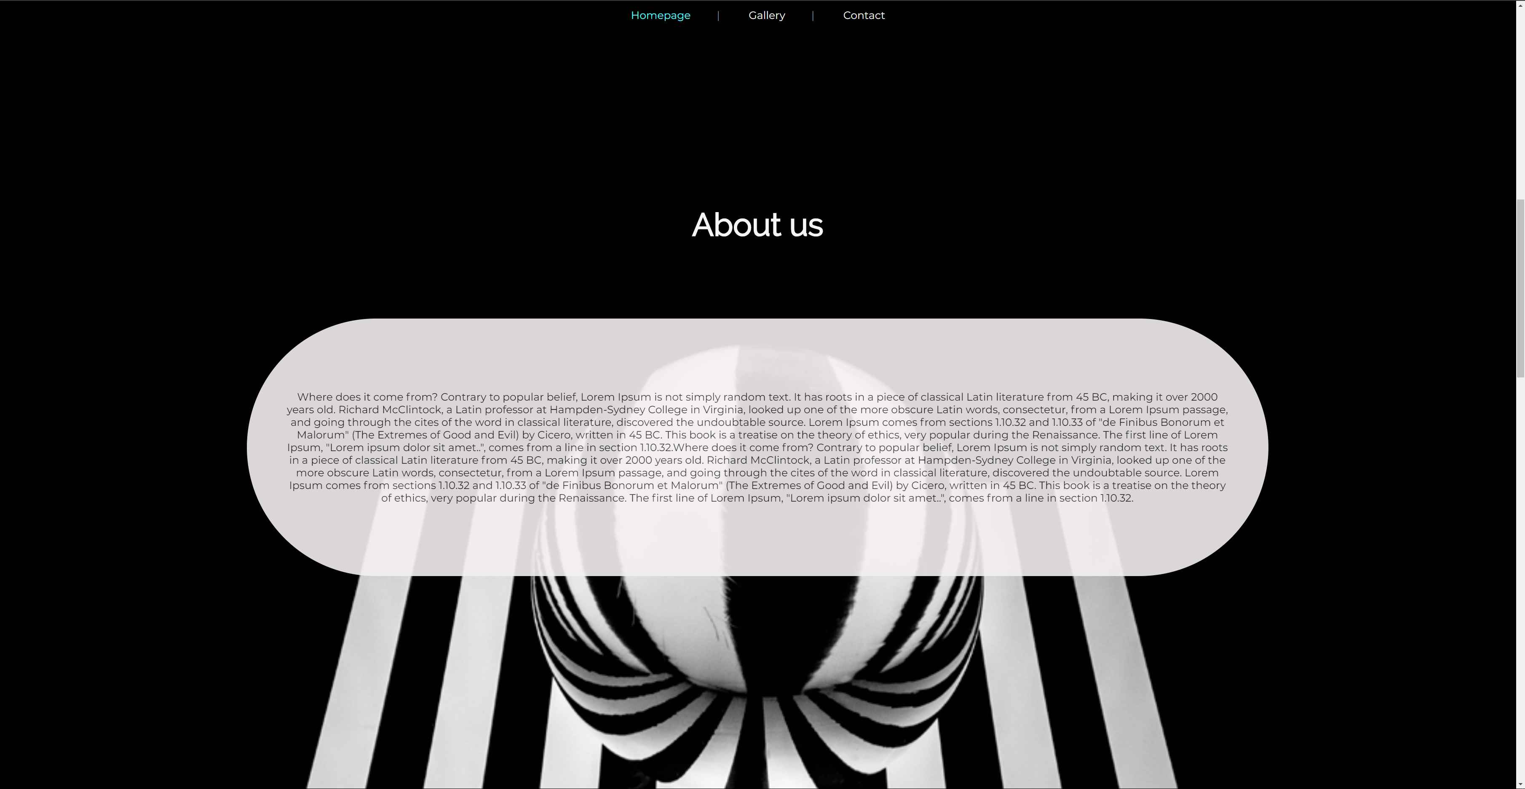

Section 3/4

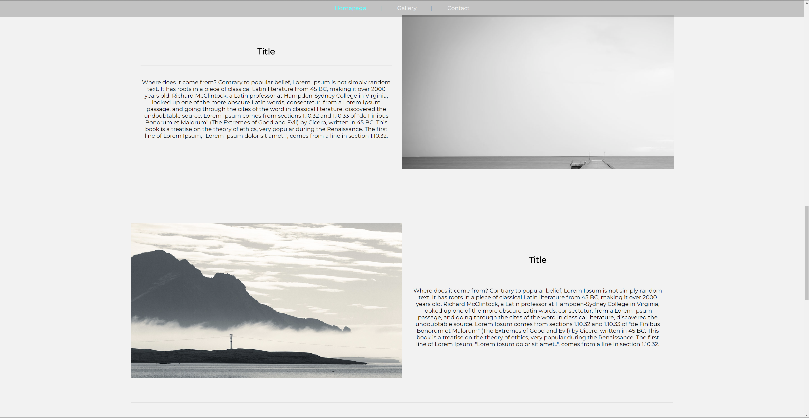

Section 4/4

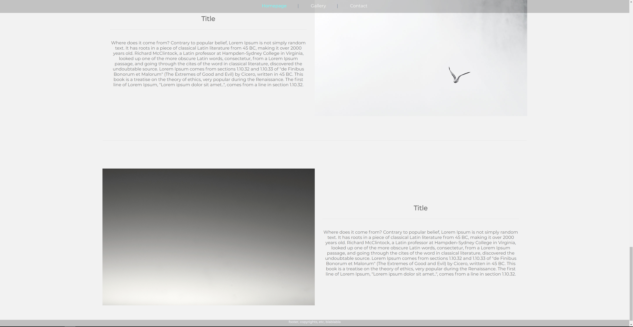

Gallery page

Section 1/3

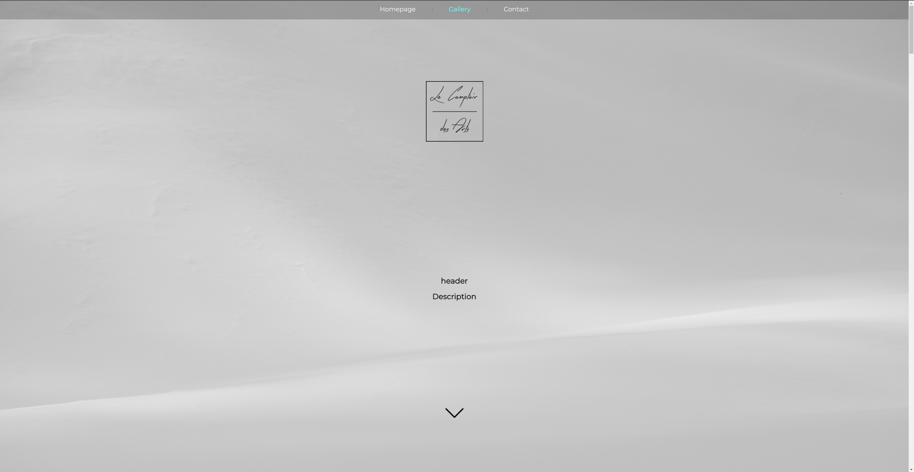

Section 2/3

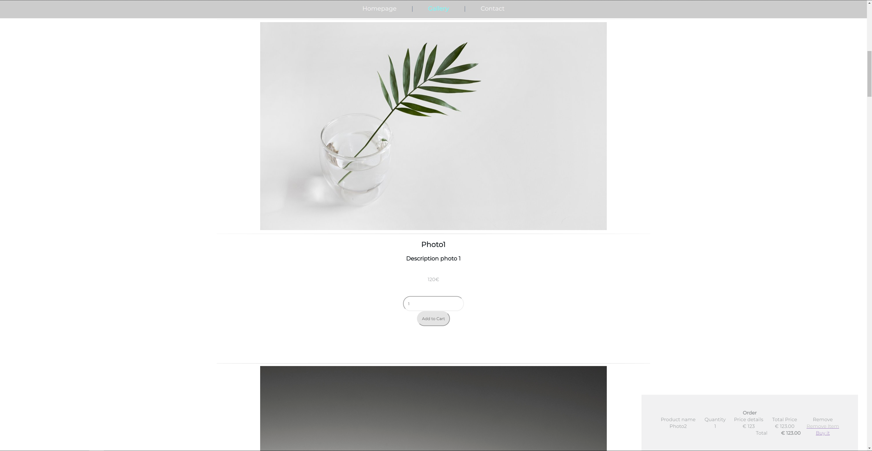

Section 3/3

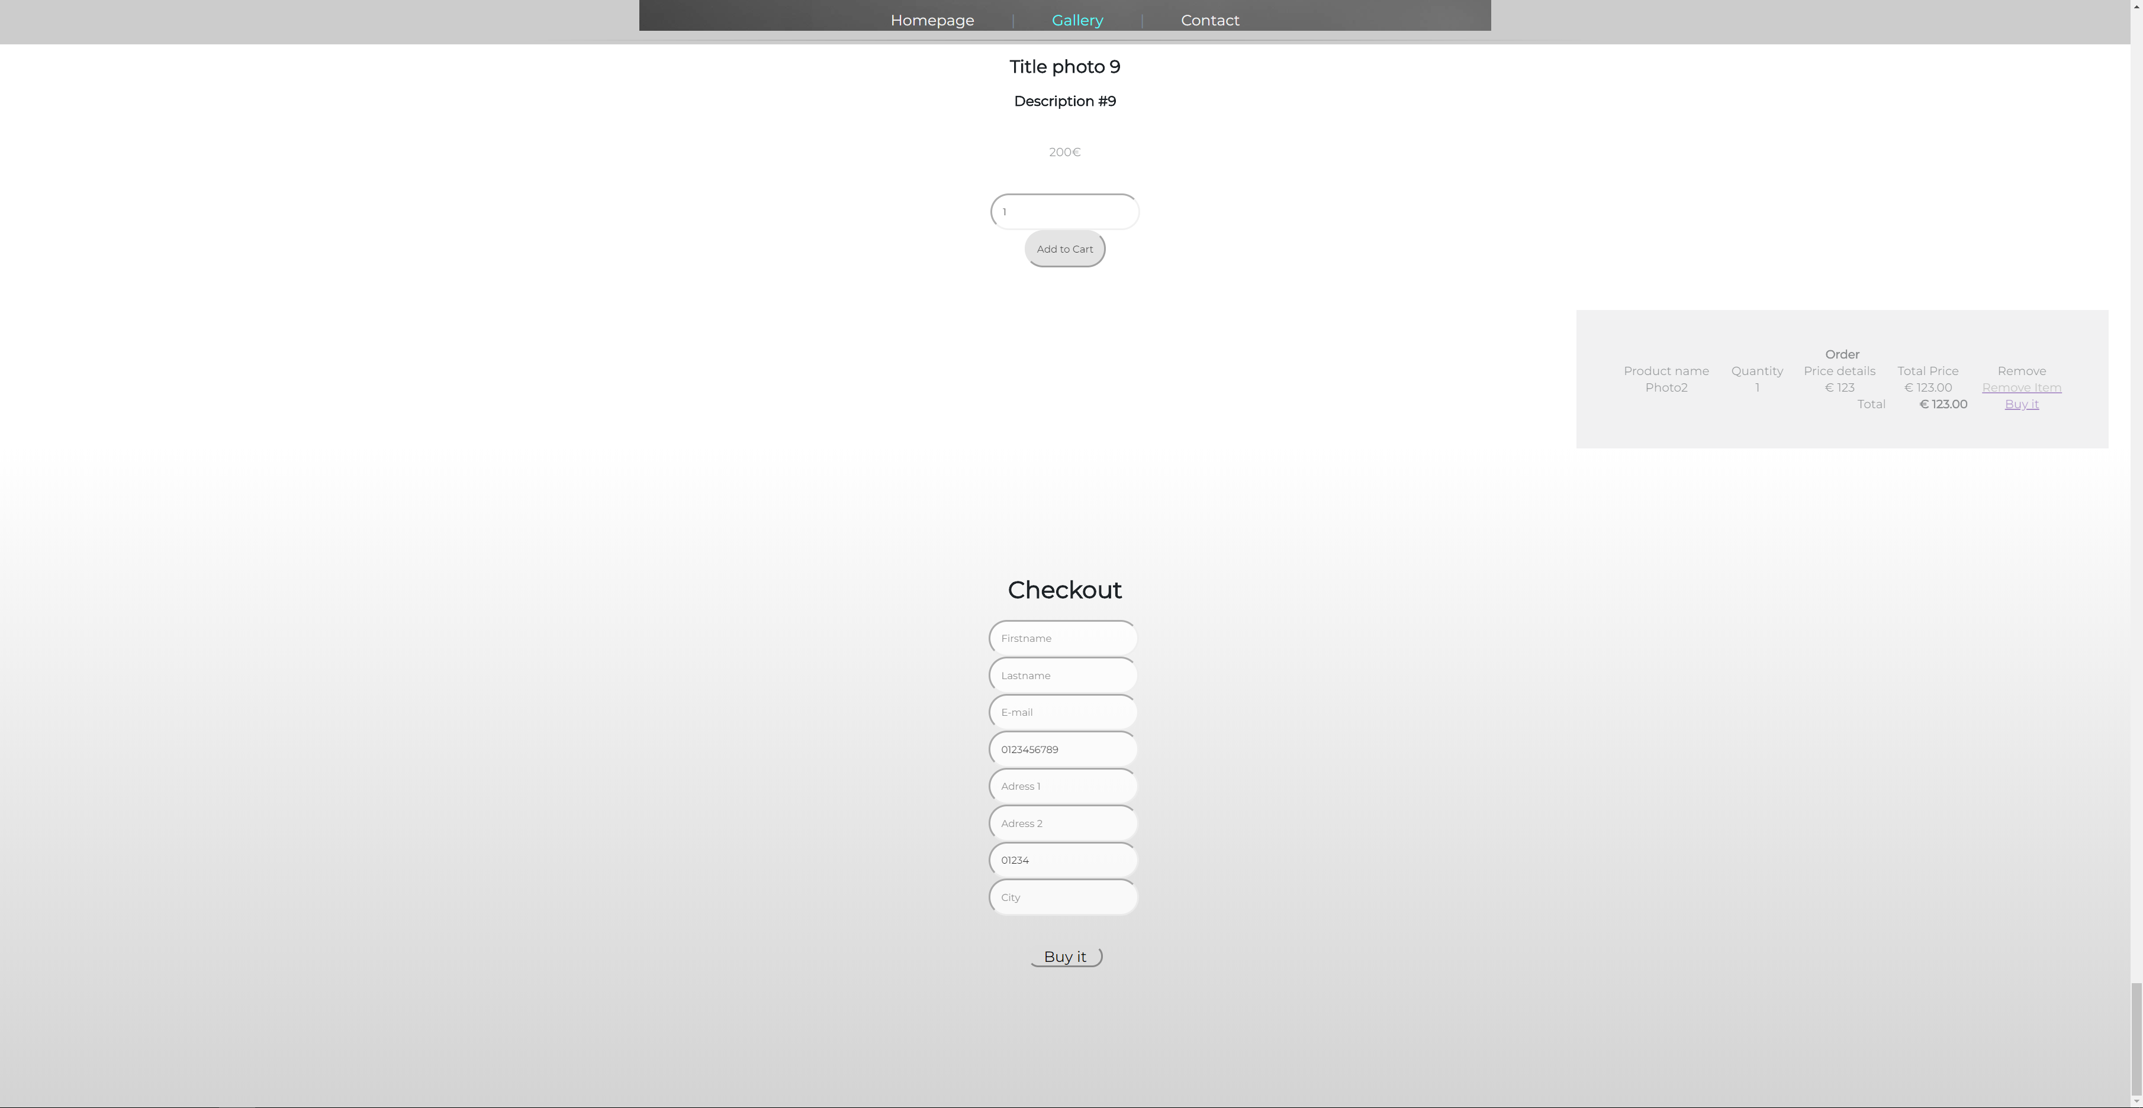

The BackEnd-Gallery

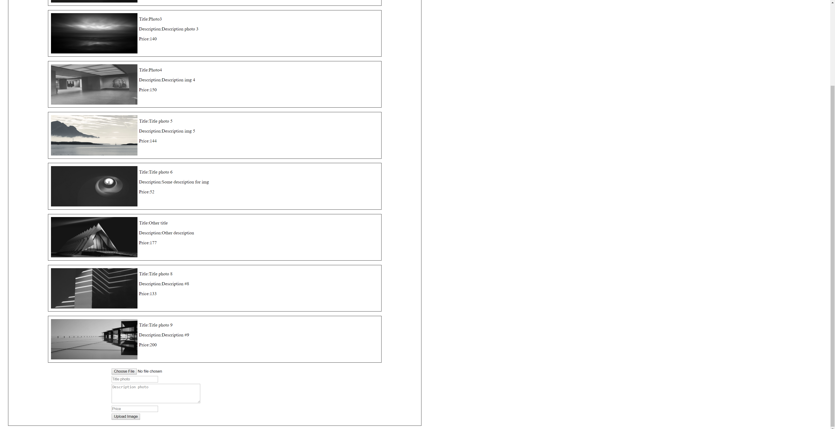

The contact

Section 1 / 1

5218695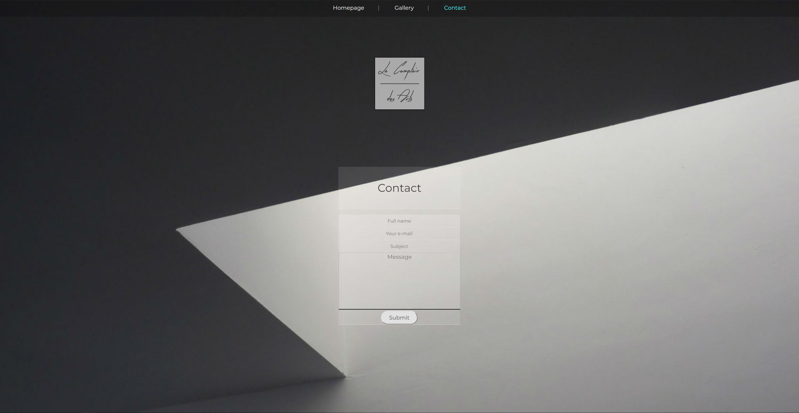

Github link:

https://github.com/SDeyn/projectweb.git

The copyrights of code and web pages are reserved to the author.